

Dear Hiring Manager,
I am interested in applying for the Office Assistant position at your company. I have strong organizational skills and experience handling administrative tasks.
In my previous role, I managed schedules, prepared documents, and supported team operations efficiently. I am confident that my attention to detail and communication skills will benefit your organization.
I look forward to the opportunity to discuss my qualifications with you.
Best regards
[Your Name]

+123-456-7890  123 Anywhere St., Any City | 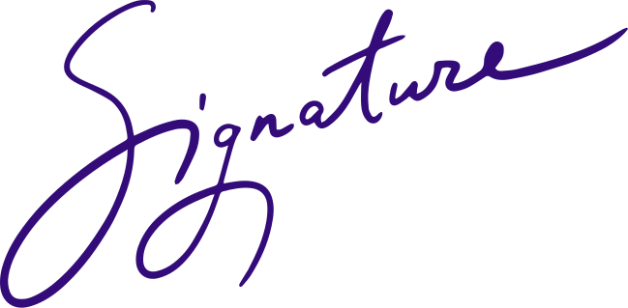  โจนาธาน แพตเตอร์สัน

